
a
Company
Logotype

Cone Beam Computed Tomography- Report



Porur Dental X-rays & CBCT

Patient Name : Mrs. Mallika | Date of Report : 13.08.2024
Age/ Gender : 43 years/ Female | Region of Interest : CBCT Maxilla Mandible
Referring doctor: Dr. M. Balamurali Sai | Indication : Implant assessment
Clinical Notes: Nil
PATIENT INFORMATION

CBCT- Maxilla Mandible provided
CBCT – IMAGE DETAILS

RADIOGRAPHIC INTERPRETATION

- Completely missing crown and root structure in relation to 14, 45.
- The maxillary and mandibular alveolar ridges are present with normal trabecular pattern.

IMPLANT ASSESSMENT

 | 14 region
Sub-Crestal (in mm) | 6.56
Mid- Crestal (in mm) | 7.55
Distance between the alveolar ridge and floor of the nasal cavity (in mm) | 20.64

 | 45 region
Sub-Crestal (in mm) | 7.43
Mid- Crestal (in mm) | 9.24
Distance between alveolar ridge and the inferior alveolar nerve canal (in mm) | 17.75
Distance between alveolar ridge and the inferior border of mandible (in mm) | 27.53

RADIOGRAPHIC IMPRESSION

- Partially edentulous maxillary and mandibular alveolar ridge.

Kindly correlate with clinical findings


IMAGES FOR REFERENCE

RECONSTRUCTED PANORAMIC VIEW
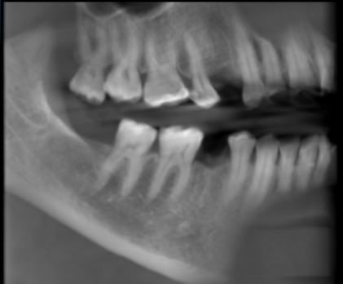

3-DIMENSIONAL VIEW

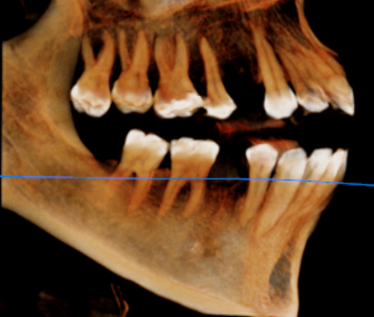

CROSS SECTIONAL VIEW

14 region | 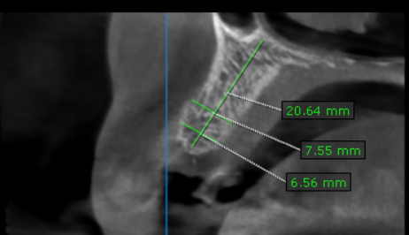
45 region | 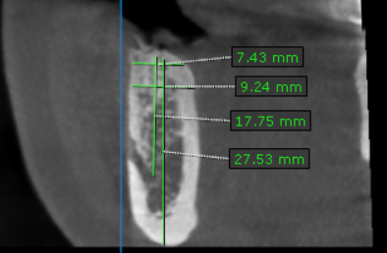

**** End of report ****

